Course Name: | Elements of Electrical and Electronics Engineering | Semester: | I/II
Date of Performance: | 16/11/21 | Batch No: | A2
Faculty Name: | Maruti Zalte | Roll No: | 16010121045
Faculty Sign & Date: |  | Grade/Marks: | / 25

Experiment No: 4

Title: Maximum Power Transfer Theorem

Aim and Objective of the Experiment:
- To observe maximum power transfer in D.C. circuit.

COs to be achieved:
CO1: Analyze resistive networks excited by DC sources using various network theorems.

Circuit Diagram/ Block Diagram:
Circuit Diagram

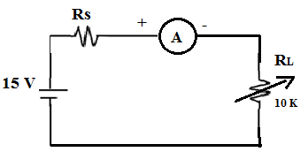
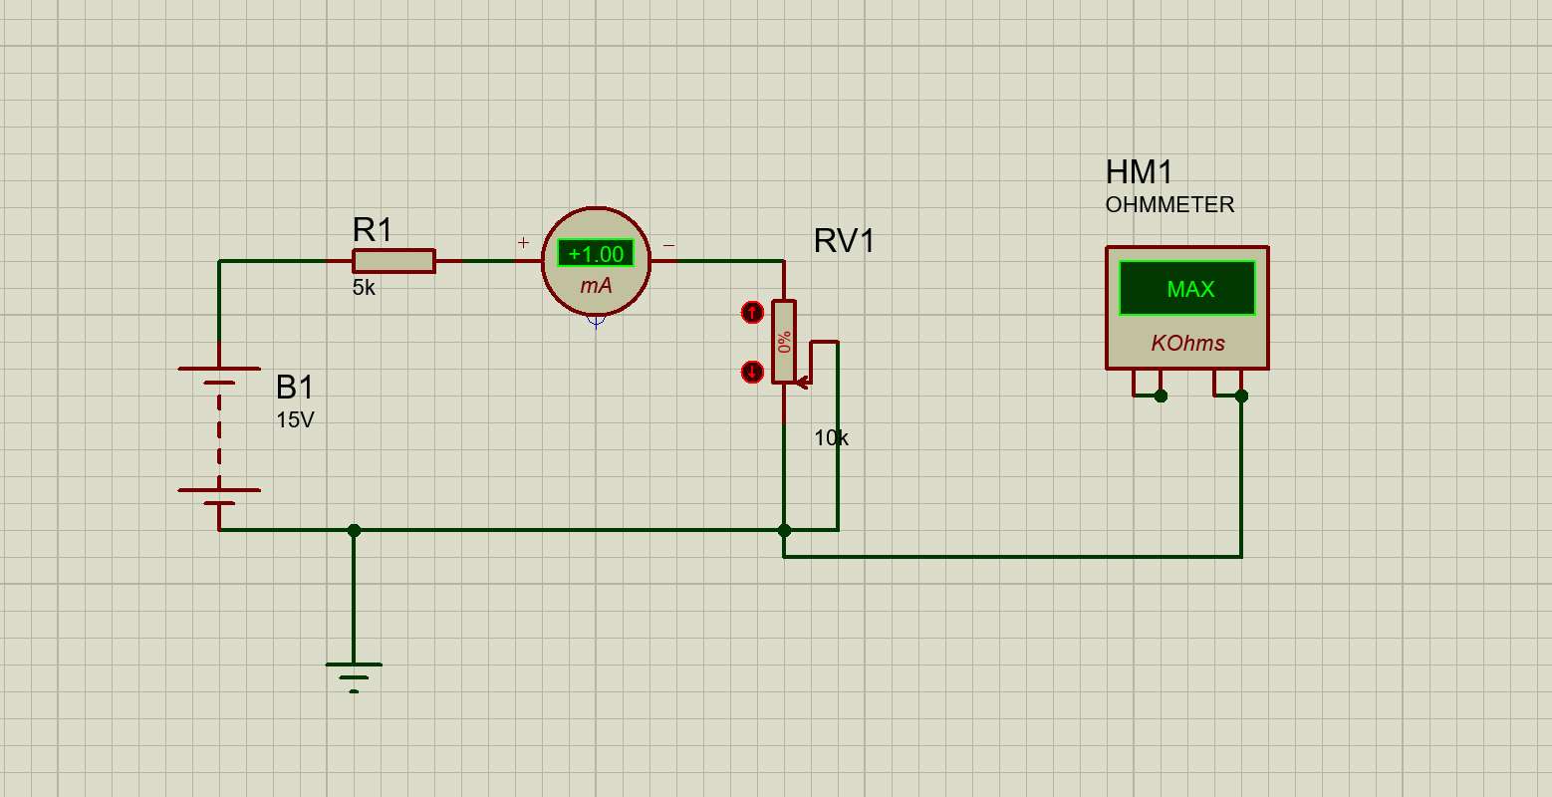
Pargat Singh

Stepwise-Procedure:
1. Set D.C. supply voltage V= 15 V.
2. Vary $R_{L}$ in the range 50 Ω - 10 KΩ in steps of 100 Ω.
3. Note down $I_{L } and V_{L}$ for each value of $R_{L}.$ Where $I_{L }and V_{L}$ are current through $R_{L}$and voltage across $R_{L}$ respectively.
4. Prepare observation table showing readings of $R_{L} Vs power P$ : $= I_{L }$ . $V_{L}$
5. Plot graph of $P Vs R_{L}$
6. Locate the point of maximum value of power $P$and note down corresponding value of $R_{L}.$
. Verify the results theoretically

Observation Table:

Sr. No. | Value of R_{L} (kΩ) | Load current I_{L} (mA) | Power P_{L}=( I_{L})²R_{L}  (mWatts)
1 | 0.5 | 2.73 | 3.72645
2 | 1 | 2.5 | 6.25
3 | 1.5 | 2.31 | 8.00415
4 | 2 | 2.14 | 9.1592
5 | 2.5 | 2.00 | 10
6 | 3 | 1.87 | 10.4907
7 | 3.5 | 1.76 | 10.8416
8 | 4 | 1.67 | 11.1556
9 | 4.5 | 1.58 | 11.2338
10 | 5 | 1.50 | 11.25
11 | 5.5 | 1.43 | 11.24695
12 | 6 | 1.36 | 11.0976
13 | 7 | 1.25 | 10.9375
14 | 8 | 1.15 | 10.58
15 | 9 | 1.07 | 10.3041
16 | 10 | 1.00 | 10

Screenshot of Output:
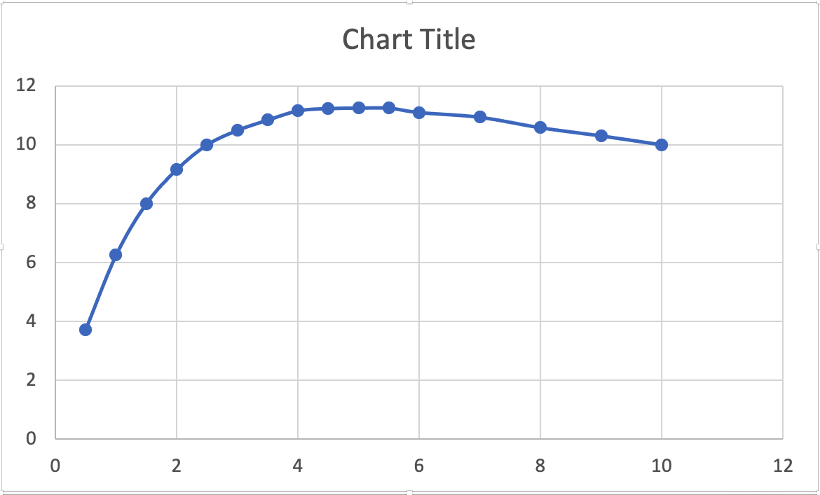
Power P_{L} (mW)
Load current I_{L} (mA)

Conclusion:
This theorem states that the maximum power that can be transferred from source to load is 50%, which occurs when source impedance is exactly matched to load impedance.

Signature of faculty in-charge with Date:

